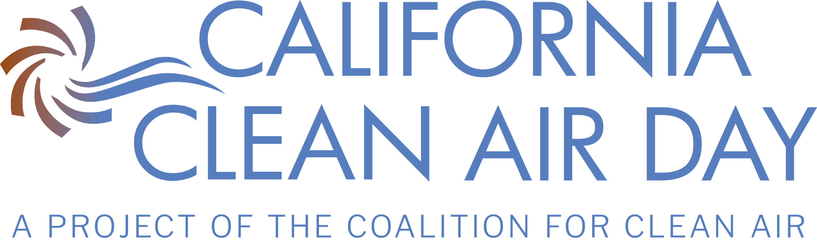
DRAFT RESOLUTION FOR
California Cities
Support for and Declaration of California Clean Air Day

WHEREAS, Air pollution contributes to higher rates of cancer and heart and lung diseases, which adversely affect health; and
WHEREAS, [_______________] has some of the worst air quality in the United States; and
WHEREAS, It is vital that we protect the health and well-being of our residents, visitors, and workforce; and
WHEREAS, Emissions from vehicles, industry, and even household sources significantly affects the natural environment, air quality and well-being of [_______________] residents; and
WHEREAS, Individual actions such as not idling vehicles, walking or biking to work and school, carpooling, and conserving energy can directly improve air quality in our region; and
WHEREAS, County employees, vendors and elected officials have tremendous power to help lower emissions; and
WHEREAS, Pledges by individuals have shown to result in action; and
WHEREAS, Education about air quality can raise community awareness, encourage our community to develop better habits, and improve our community health; and
WHEREAS, Californians will be joining together across the state to clear the air on October 5, 2022; and
WHEREAS, [_______________] is committed to the health of our residents, workforce, visitors, and community at large; now, therefore be it
RESOLVED, By the [_______________] that the first Wednesday of October be declared “Clean Air Day” in the district; and be it further
RESOLVED, That our departments ask their employees to take the clean air pledge for California Clean Air Day; and be it further
RESOLVED, That we encourage all residents, businesses, employees, and community members to participate in Clean Air Day and help clear the air for all Californians.

