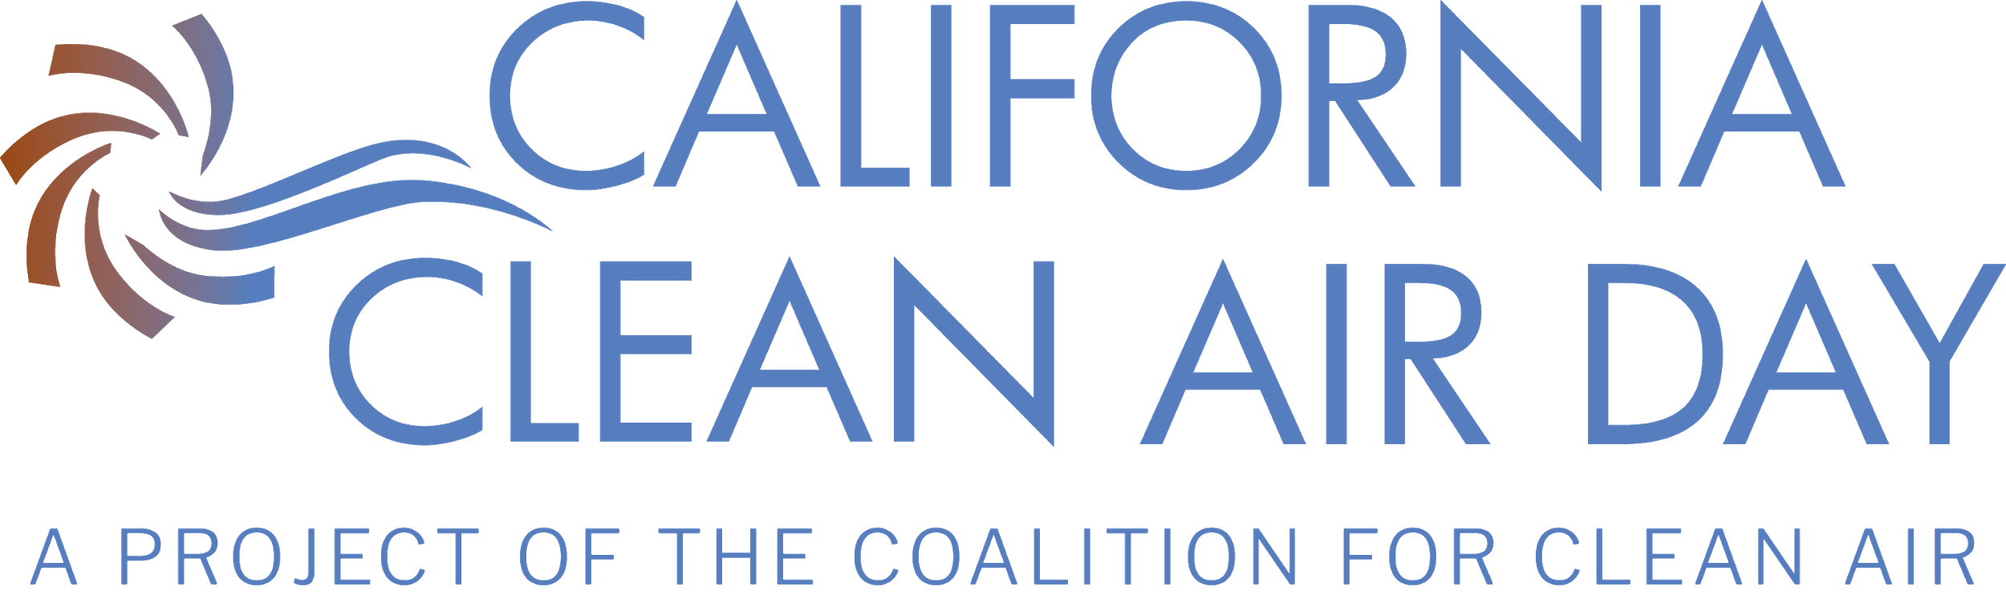
DRAFT RESOLUTION FOR
California Cities
Support for and Declaration of California Clean Air Day

Whereas, air pollution contributes to higher rates of cancer and heart and lung diseases, which adversely affect health; and
Whereas, compromised lung health has been linked to poor outcomes in people infected with COVID-19; and
Whereas, California has some of the most polluted regions in the United States; and
Whereas, early studies find that people with COVID-19 who live in U.S. regions with high levels of air pollution are more likely to die from the disease than people who live in less polluted areas, according to a new nationwide study from Harvard T.H. Chan School of Public Health; and
Whereas, it is vital that we protect the health and well-being of our residents, visitors, and workforce; and
Whereas, emissions from vehicles, industry, and even household sources significantly affects the natural environment, air quality and well-being of residents, employees, and visitors of the City/County of XXXXX; and
Whereas, individual actions such as not idling vehicles, walking or biking to work and school, carpooling, and conserving energy can directly improve air quality in our region; and
Whereas, everyone can play a role; and
Whereas, taking the pledge and participating in California Clean Air Day can be accomplished safely while wearing face coverings and practicing social distancing in your own household or neighborhood; and
Whereas, education about air quality can raise community awareness, encourage our communities to develop environmentally healthier habits, and improve our communities’ well-being; and
Whereas, Californians will be joining together across the state to clean the air on October 7, 2020; and
Whereas, the City/County of XXXXX is committed to the health of our residents, workforce, visitors, and community at large; and
Now, therefore be it resolved, by the City/County of XXXXX that October 7, 2020 be declared “California Clean Air Day” in the City/County, and
Be it further resolved that we ask all City/County Department heads to determine how their employees can participate in California Clean Air Day, as appropriate, and report back on those actions.
Be it further resolved that we encourage all residents, businesses, employees, and community members to participate in California Clean Air Day and help clean the air for all Californians.

